상표 확인 09

<http://kdtj.kipris.or.kr/kdtj/searchLogina.do?method=loginTM#page1>

앱 아이콘 리사이징

<https://appiconmaker.co/Home/Index/930f29c0-e892-43a5-9cd0-94f15de6b07b>

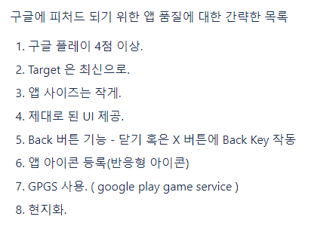

1. 대시보드 가이드:

<https://github.com/unity-kr/unityads-help-kr/wiki/Dashboard-guide>

1. 최신 SDK

* Unity-Ads-Android:

<https://github.com/Unity-Technologies/unity-ads-android/releases>

* Unity-Ads-iOS:

[ttps://github.com/Unity-Technologies/unity-ads-ios/releases](https://github.com/Unity-Technologies/unity-ads-ios/releases)

* Asset Store:

[Unity Monetization Legacy (Please get from Package Manager) | Services | Unity Asset Store](https://assetstore.unity.com/packages/add-ons/services/unity-monetization-3-3-0-66123)

1. SDK 연동 가이드:

[Welcome to Unity Ads - Knowledge base](http://unityads.unity3d.com/help/index)